- Introduction :
About book my show

- Ashish hemarajani started bigtree entertainment Pvt.ltd in his bedroom in 1999.
- Parikshit dar took over technology & rajesh balpande took over finance are both came in as co-founders.
- 1st investor – jp moragan chase.
- No investors from 2002 to 2006.
- Automated ticketing software.
- Company jumped from Nil to a 21.4 cr. Valuation (2007)
- Network 18 invested 14.5 crs.

- History :

- Book My Show started out in 1999 as a software re-seller for movie theaters and converted into a platform catering to cloud-based ticket booking of events, movies, sports, and plays.
- According to a Red Seer report, the online ticketing market in India has recorded a quarterly revenue of $28 million.
- Book My Show has achieved 40% CAGR in revenues.
- Book My Show was initially branded as ‘Go For Ticketing’. In 2002, the company was renamed ‘India Ticketing’ before ending up with the current name.
- The name Book My Show was suggested by an engineering intern.
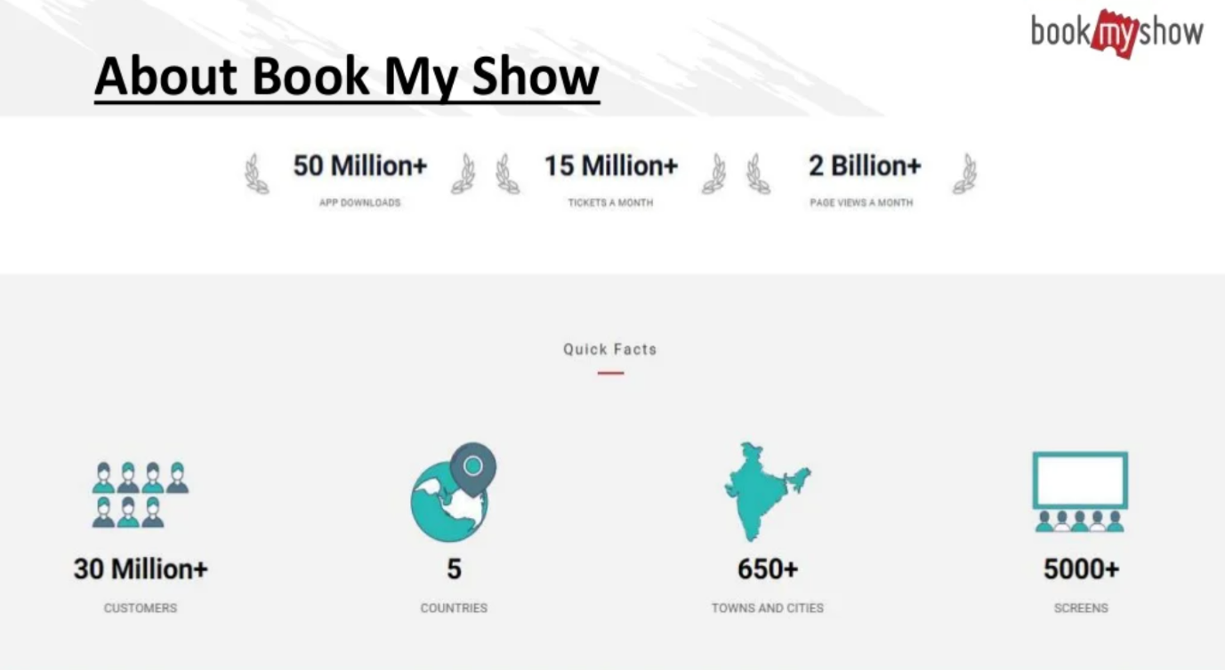

3.Type – Service Based

It provides event ticket before the show online.
It provids –:
1.Movie Ticket
2.Event Ticket(Comedy shows,Meetup etc)
3.Meals

4.Technical Specification :

A. Website :- https://in.bookmyshow.com/
B. App :- Book My Show.
C. Devloped in :- Html,css, javascript, mysql.

5.FUNCTIONALITIES OF SYSTEM :

1.Book Movie Ticket
2.Can Order Meal During Show
3.Can Host the show
4.Can manage the show (Place , Timing , Ticket etc)
5.Book sports matches tickets
6.Can buy movie on rent.
7.Can stream event
8.Can play online games(Have to buy)
9.Workshops(Manage, List , Watch)
10.Host Compitions.

6.ROLE OF CUSTOMER :
Ways To Download
- You can download it from play store or from direct web site.

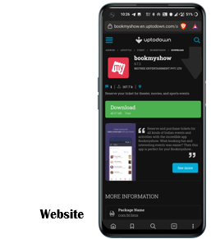
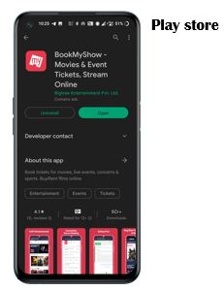

Login page

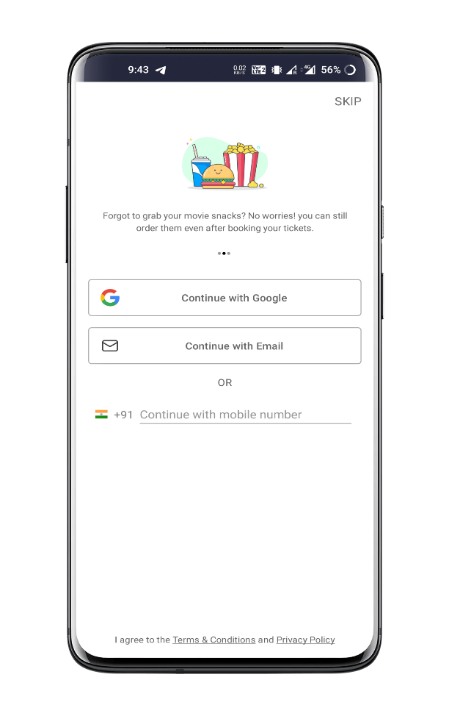
- There are total 3 way to login into in.
      - Google account
      - Email
      - Mobile number
- You can also skip it for now

- After entering Gmail or Email or phone It will send you a O.T.P. to confirm Your Identity.
- In the next page we gave 2 example of login with otp method.

OTP Method

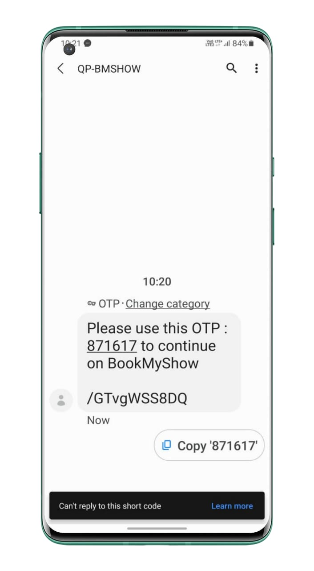
1.Phone Number 2.Gmail/Email Login
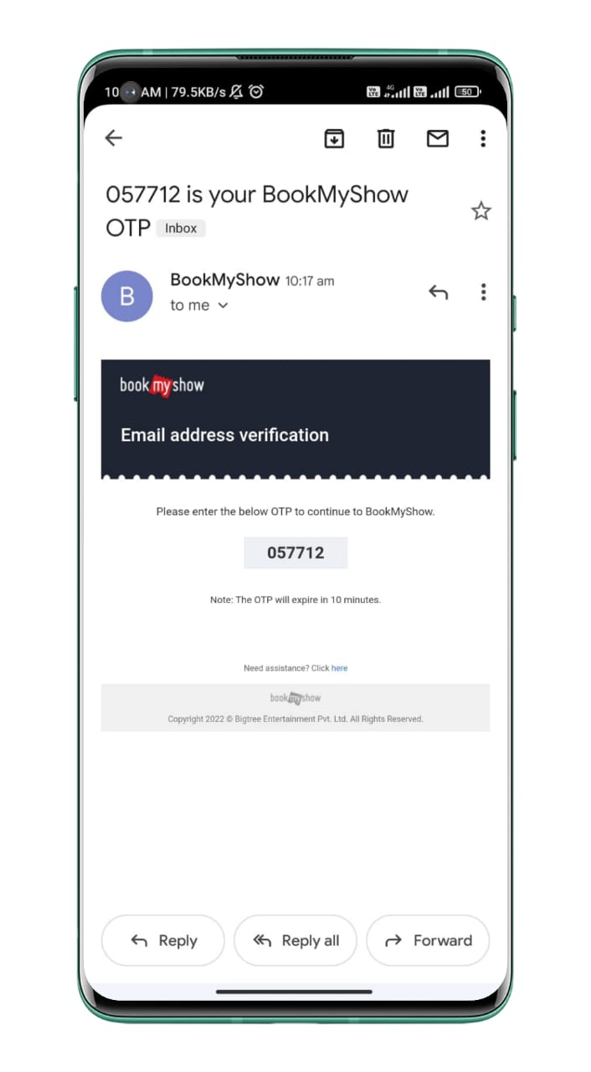

Location
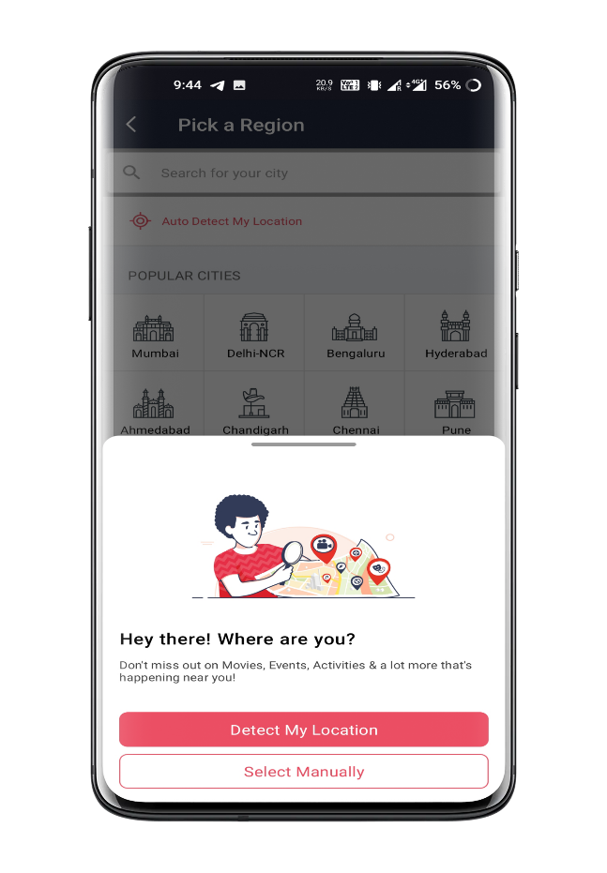

- After login it will ask you to enter your location.
- There are two way to feed it location.
          - Detected my location automatically by GPS
          - Select manually.

Home Page

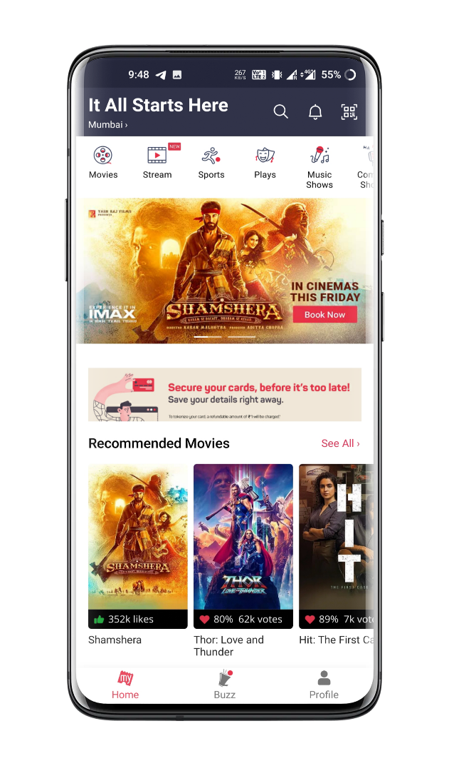
- In home page you will find so many option such as booking or watch the movie online etc.
- On home page shows multiple option on upper side like live streaming, sports, comedy, music shows.
- It also provide workshop and kid zone.
- you will find:
1. A search button
2. Recommended movie
3. Q.R. Code scanner

Search
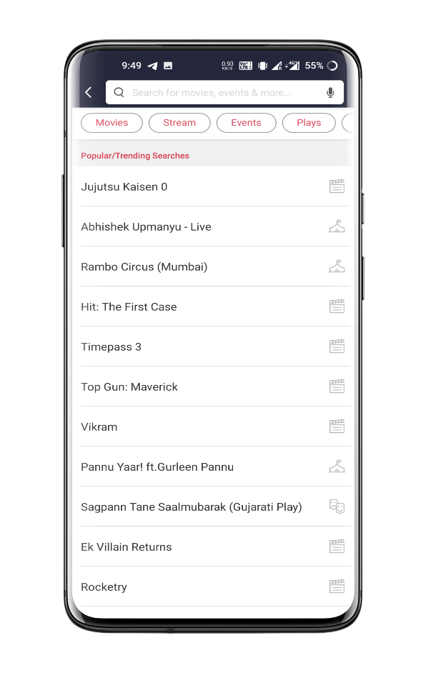

- You can search movie, cinema hall, event etc
- It will also recommended you trending event and movies
- Select what you want

Booking Ticket
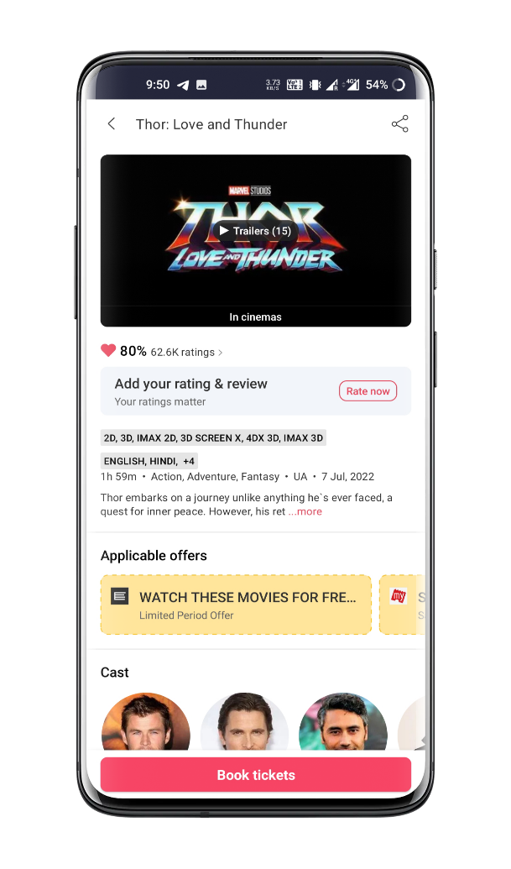

- After selection you will have the quick detail of the show .
- In detail you find short information about the show
- To book the ticket press on the bottom button ‘book ticket’

Date, Time And Cinema hall Selection

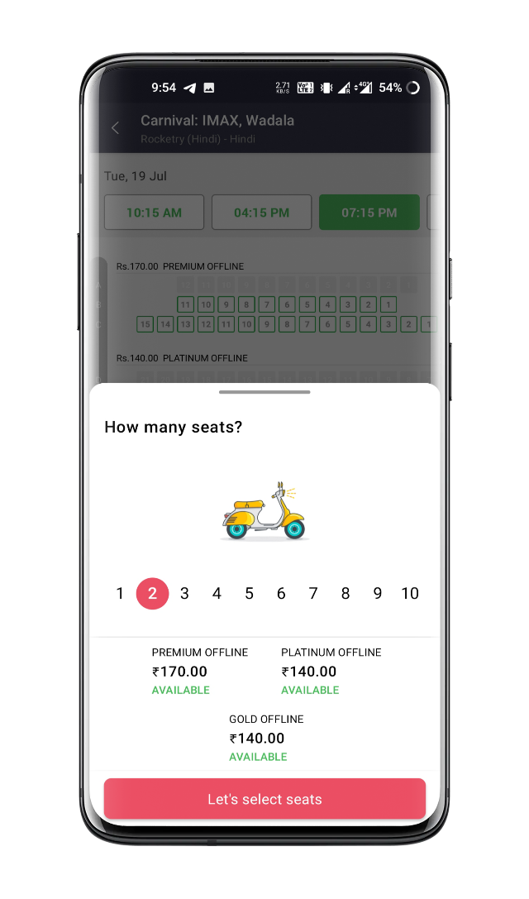
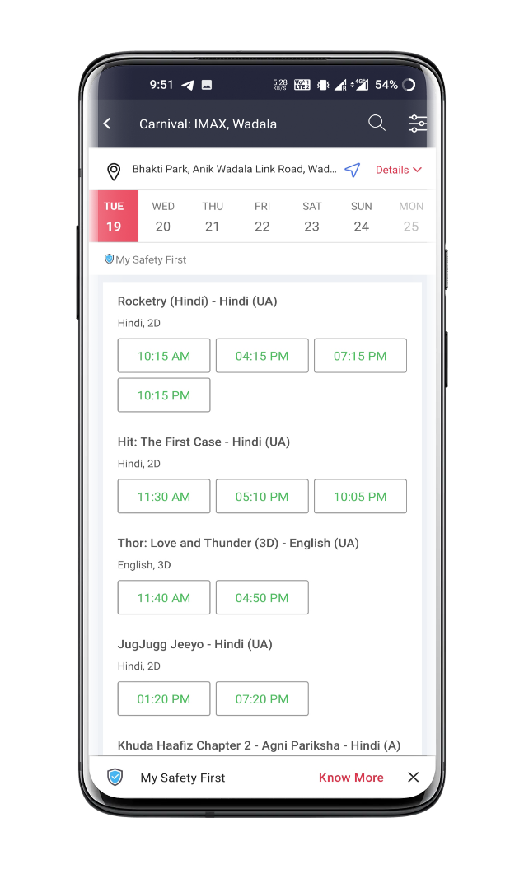

- Now you have to select time, hall and date according to your comfort.
- Here also have filter for accurate result.
- Then select seats and it will show you the total amount and various selection.

Seat Selection

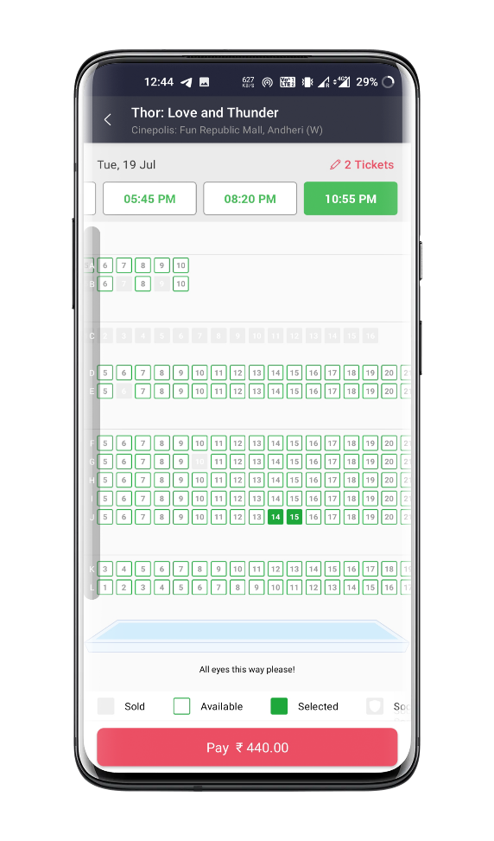

- Here you can select seats you want
- If seats already booked then it show in red colour, available seats show in green colour.
- Here we can see date and time of the movie as well as screen direction.

Pop up

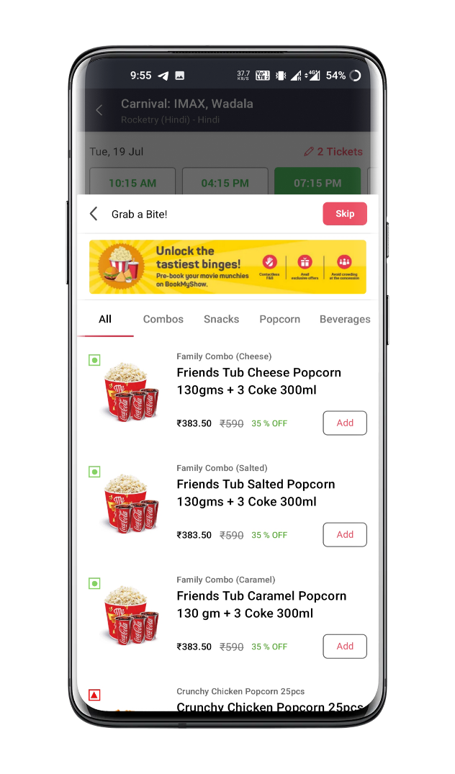

- A screen will pop up like this, to ask you about beverages.
- If you want it then choose what you want, otherwise you can skip it.

Invoice

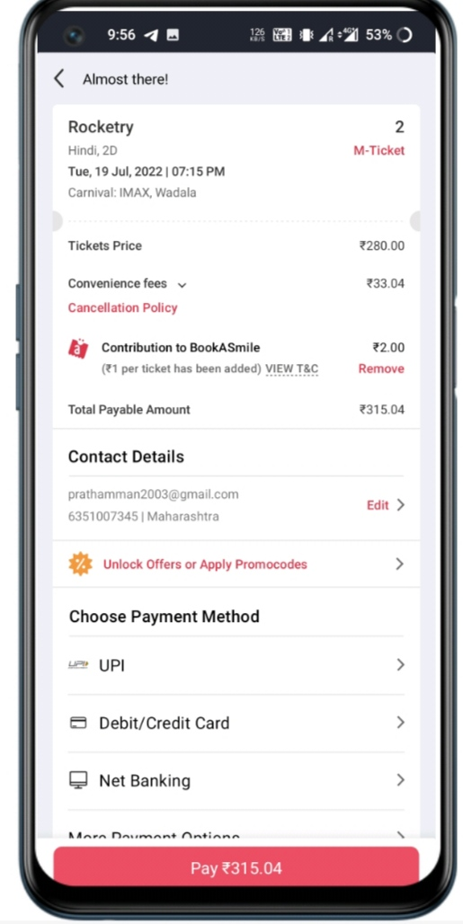

- Here we have the invoice of the ticket with every possible details.
- Also we have several payment option.
- Also same offers.

Buzz Services

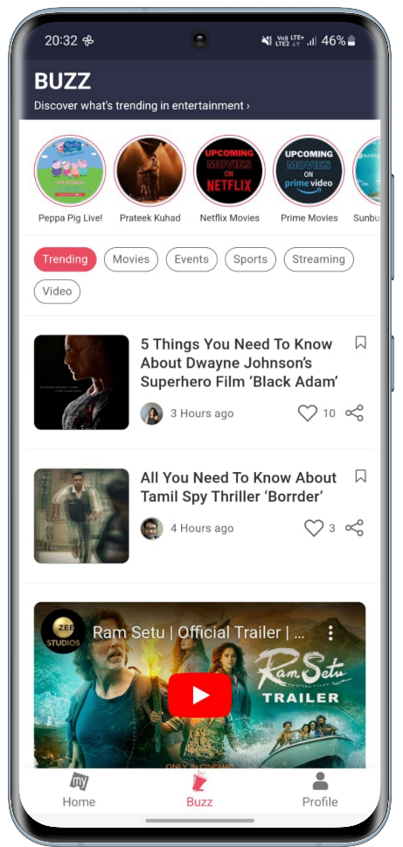

- Buzz services are used to discover what’s trending in entertainment
- Buzz discovered are below
- Trending
- Movie
- Event
- Sport
- Streaming
- Video

Profile

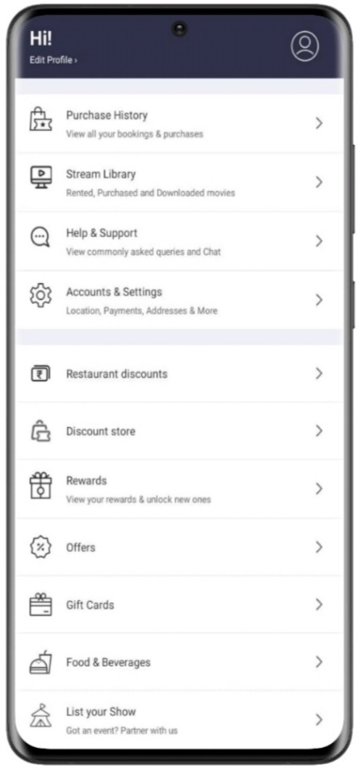

- In profile section we found many option
- Purchase history
- Reward
- Restaurant discount
- Discount stores
- Offers etc.

Help and Support
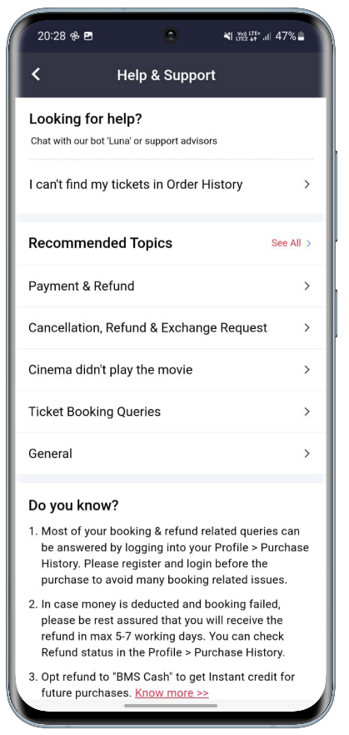

- Help & support are help like can’t find ticket order history
- Recommended topic
- Payment & method.
- Cancellation
- Refund, exchange request.
- Ticket booking queries.
- General.

Cancellation process

- You can cancel the ticket 4 hours before the show and refund will be done according to cancellation policy.
- If you booked via credit and debit card, the card owner must be present at time of taking.

7.Role of Seller :-

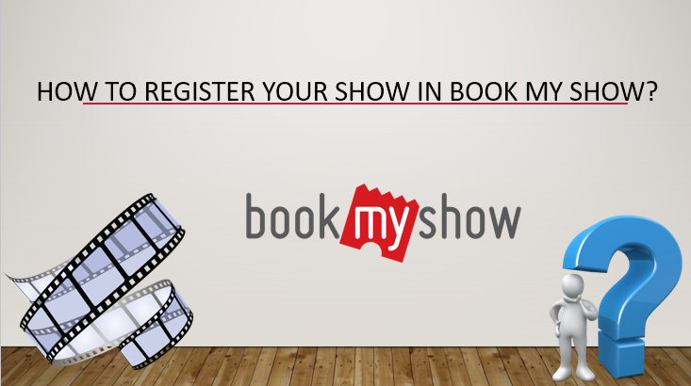

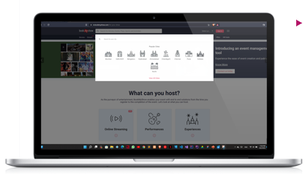
City selection

- First of all you have to select city where you want to do your program or your theatre location.
- After selection it will redirect to that city page .

Main page
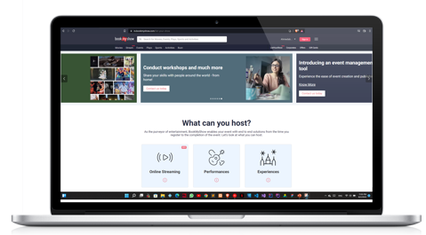

- After selection of city you will be directed to main page where you will find many option.
- Some detail of hosting and etc.
- Also you can book movie ticket from here.

Hosting detail

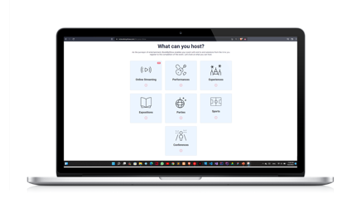
- In Above Example it shows What can you List On Book My Show.

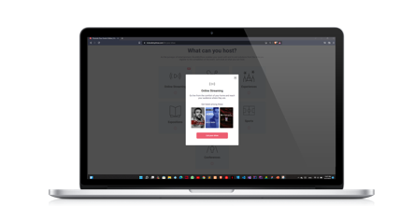
- Some detail about hosting, such as what can you host etc .

Services And List Button
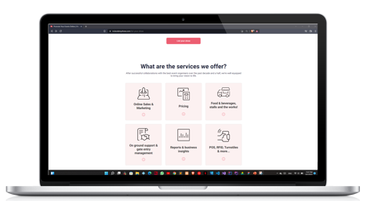

- Here we have some detail of services
- And a button which redirect you to register page

Confirmation page

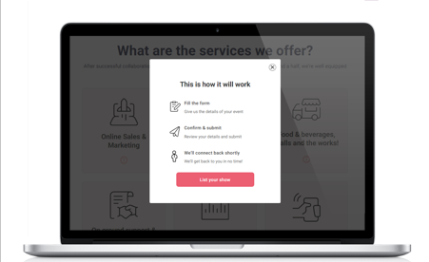

- After clicking on list your show it will show you a confirmation.
- Just like this.

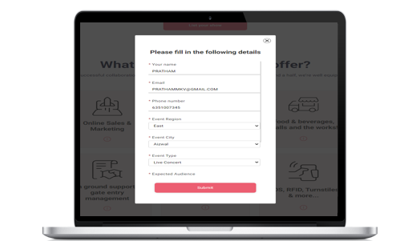
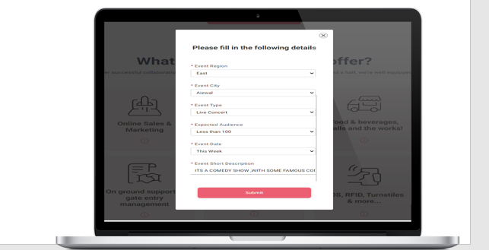
Filling up detail

- After confirmation it will ask you about detail of show.
- Just like this.

Types of Events

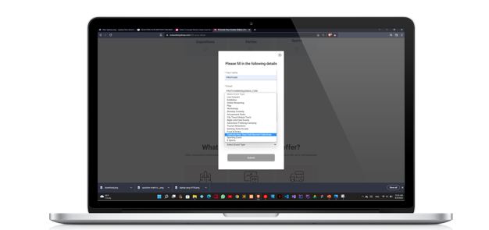

- Various type of event you can select.

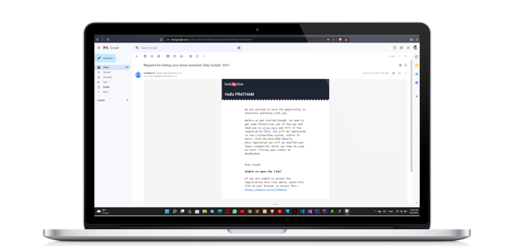
Confirmation email

- After submitting the detail you will get an confirmation email on tour regidterd mail id.

Google form

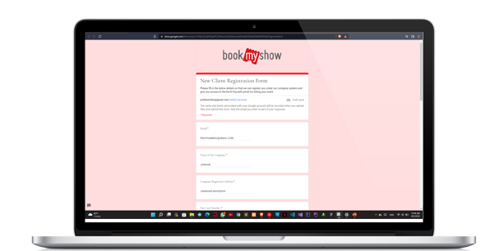
- After filling up the google form you will be good to go
- After verification you will be registration you will be registered successfully

8.Role of Other

Net banking

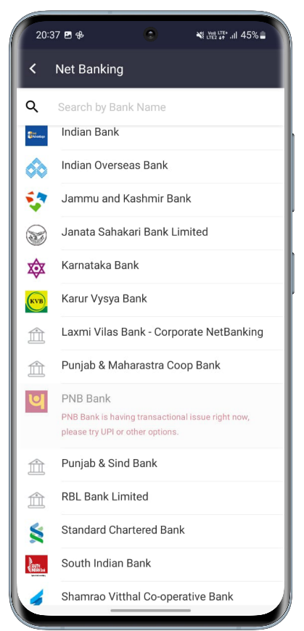
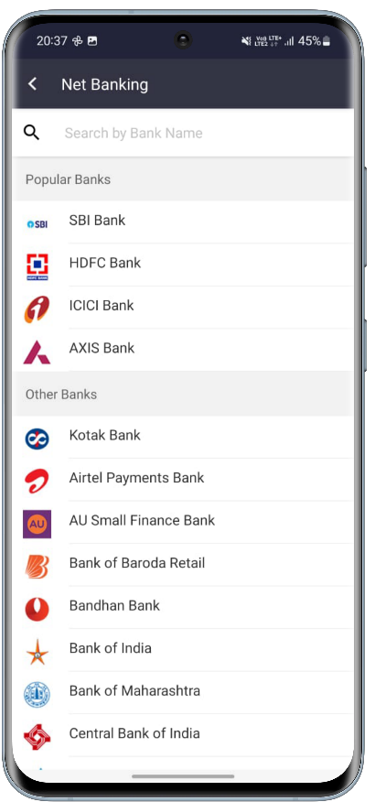
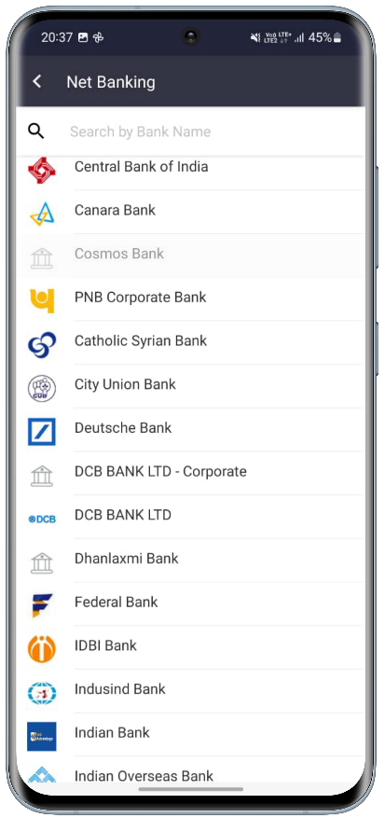

Select bank name of your bank account

After Selecting Bank

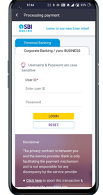

- First we have to enter user id
- Password and click login
.

9.Payment Type And Flow

Payment Methods

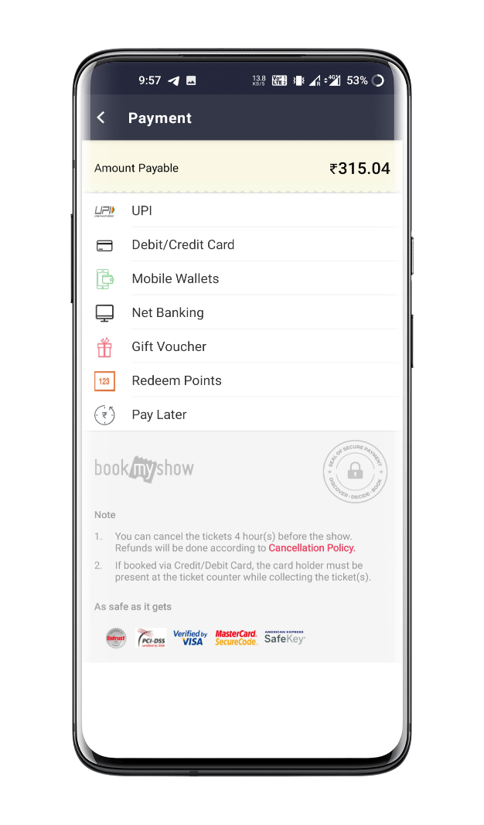
Here we have the several payment option

- UPI.
- CREDIT AND DEBIT CARD.
- MOBILE WALLET.
- NET BANKING.
- GIFT VOUCHER.
- REDDEM POINT.
- PAYMENT LATER.

MULTIPLE PAYMENT OPTION

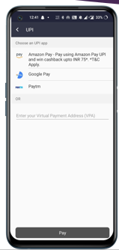
- UPI Payment option.

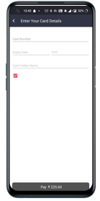
- Payment option through Dabit and credit card

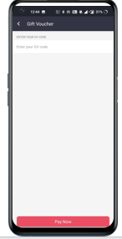

- Payment throught gift voucher

- Payment throught mobile wallet

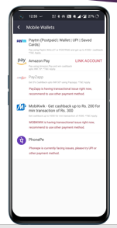

Net Banking

      - After all we have many payment bank.
      - For ex if we select SBI bank then it will proceed us to SBI’S portal.
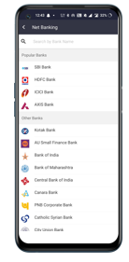
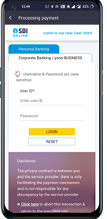

Payment later

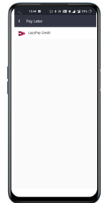

- We have pay later option in which we can pay money later, on credit.

10.Advantages :
- stress-free, hustle free booking of tickets
- Easy payment options
- Various additional schemes to avail on dis booking
- Supply when u have an account of site firm where u r doing booking
- You can have various options while choosing our tickets

Disadvantages :
- software glitch can cause u buy same ticket twice. And then u have to contact Cust care and stress ourself for reversal
- Unfortunate network loss while paying online can leave u in confusion whether u have paid or have to Again contact Cust care.
- Some time u do online booking but still u have to take trouble collecting those printed passes.

